Gradient Vector Field

Initially Pacman image is smoothed by applying a discretized approximation of the Gaussian filter. Gradient vector field (u,v) is found using the euler equation given in GVF paper

Mu\*Lap(u)-(u-Ix)\*mag(gradient(I))

Mu\*Lap(v)-(v-Iy)\*mag(gradient(I))

Gradient vector field (u,v) is found through an iterative process. (u,v) is initialized to (Ix,Iy) where Ix,Iy is the gradient of image I. Then at each iteration

Unext = (1-B)\*Upre + 4\*r\*Lap(u) + c1

Vnext = (1-B)\*Vpre + 4\*r\*Lap(v) + c2

Where B = mag(gradient(I))

C1 = B\*Ix

C2 = B\*Iy

The initial, intermediate and final steps of the evolution process are show below

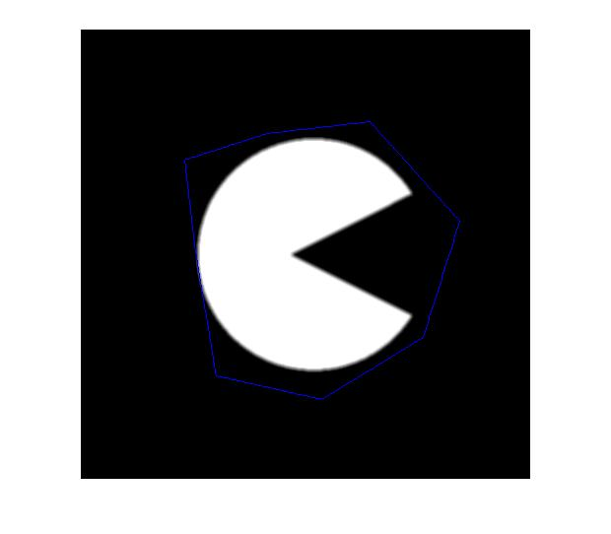

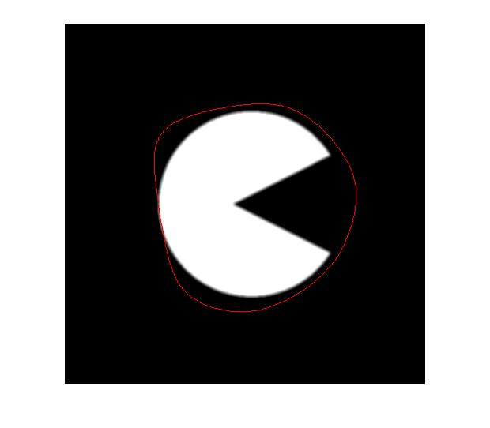

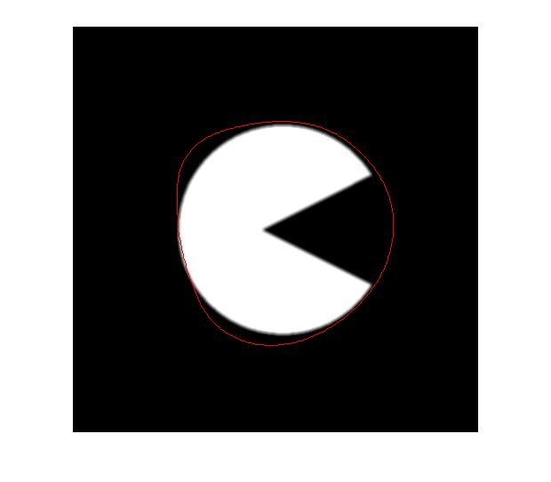

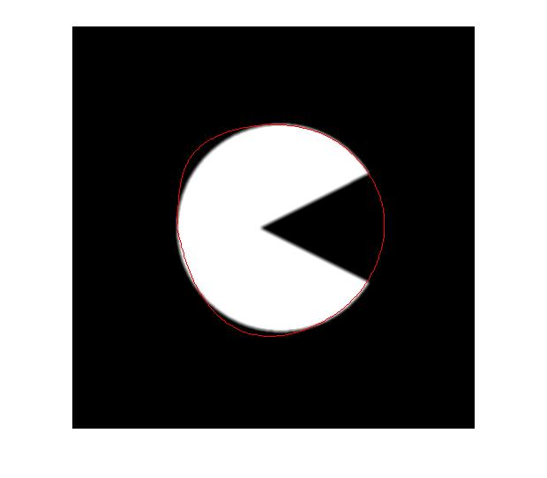

Implementation Issues: I have implemented the iterative equations as described above and as in the GVF paper but the result I get is that of a traditional snake.(not going into the convex curve).